C:\Program Files\Microsoft Office\MEDIA\CAGCAT10\j0185604.wmf **Home is where your Story Begins**

**And where your heart will always lead.**

**Katie’s was “5” when her family moved to a Home in “Wheaton”**

**And at “25” she met & fell in LOVE with a man named “Hiten”.**

**Their jobs brought them both to DC & happy they surely would be**

**But now a baby is expected and soon they will be a family of three!**

**So they moved from their condo near Washington DC**

**To a home in Wheaton on a street called Liberty!**

**Planted deep in the roots of this love story it seems**

**Is the hand of the Creator guiding all of these dreams**

**Very** **soon** **a “New Chapter” of their lives will unfold**

**And into their arms a baby girl they will hold!**

**Katie and her sisters had lots of “tea parties” & little girl play**

**And with these fond memories we are having a “tea party” today!**

**And so to this sweet little baby we shower today with our love**

**We ask for God’s blessings on this precious new life , surely a gift from above!**

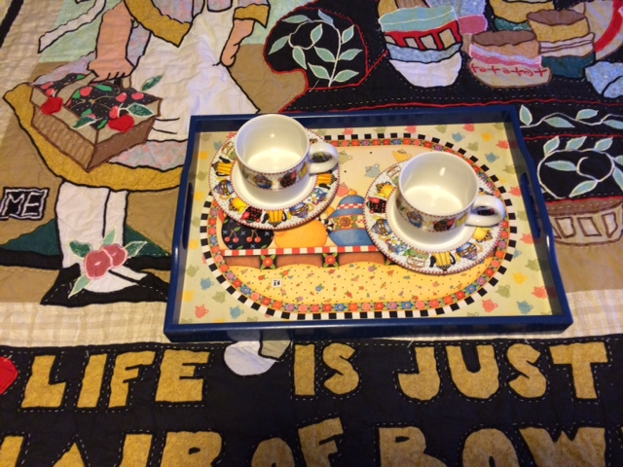

**Baby will be welcomed by lots cousins who all love a good party!**